|  |
| --- |
|  |
| Environmental Monitoring and Prediction System |
| Software Design Specification |
|  |
| **Trevor Howat** |
| **7/28/2024** |

|  |
| --- |
|  |

Table of Contents

System Overview 2

Problem Statement 2

System Functionalities 2

Target Users 2

Business Goals 2

Non-Functional Requirements 3

Use Cases 4

Actors 4

Use Cases 4

Register with System 4

Collect Environmental Data 5

Set an Alert 6

Configure New Sensor 7

Generate Prediction Model 8

Use Case Diagram 9

# System Overview

## Problem Statement

Climate change has led to an increase in the severity and a decrease in the predictability of weather. It is imperative for the safety of communities and the functioning of our society that a system be created to monitor, predict, and communicate both short and long term environmental conditions to experts and the public.

## System Functionalities

The EMPS system will collect a variety of environmental data points and process it for use in creating environmental models and for input in prediction algorithms. It will also provide a way for the user to visualize the data collected and processed, as well as the models and predictions created using the data.

## Target Users

1. Research Institutions
   * Collect data to use for research
   * Analyze data to find short and long term trends
   * Use predictions and models as sources for research
2. Local Communities and Governments
   * Information on current and short term weather conditions to make public safety decisions
   * Use models for disaster preparation
3. Large Government Agencies (State or Federal)
   * Access to relevant and accurate information to use in policymaking and setting regulations
   * Access to accurate models for weather events such as hurricanes and tornadoes to assist in disaster preparedness
4. General Public
   * Access to accurate short term weather forecasts for day-to-day planning of life
   * Access to accurate models of potential disasters for personal safety
5. Non-Government Industry and Business
   * Accurate weather models and predictions in order to optimize business operations and use of resources

## Business Goals

1. Support Decision Making: Provide data and predictive models to help decision makers make informed decisions about public safety, policy making, and business decisions.
2. Improve Risk Management: Provide accurate models and predictive capabilities to mitigate the effects of large scale natural disasters on the people, infrastructure, and operations of a community.
3. Facilitate Research and Development: Support Research and Development efforts by providing data and models that display the short and long term effects of Climate Change.
4. Enhance Environmental Sustainability: Provide accurate environmental readings and weather models to highlight and encourage the need for sustainable practices in industries.
5. Build Partnerships: Work with industries and governments at all levels to incorporate the EMPS system for mutual benefit.

## Non-Functional Requirements

1. Performance:
   * The system shall be able to scale horizontally to add new sensors or stations and vertically to handle increased data volume as the system grows
   * The system shall have an average response time of no more than 30 seconds for data retrievals from the database and no more than 5 minutes for generating models or predictive patterns
   * The system shall be able to handle a data throughput of up to 2 Gbps
2. Security:
   * The system shall require users logging in to use two factor authentications to ensure their identity is verified
   * The system shall require that all data transmitted within the system must be encrypted with industry standard encryptions to prevent data breaches
3. Maintainability:
   * The system shall be designed with low coupling and high modularity to allow systems to be substituted out in the future
   * The system shall maintain up to date documentation on both how the system works and how it is used by users
   * The system shall maintain comprehensive unit and integration tests that follow industry standards
4. Reliability:
   * The system shall be designed to handle faults gracefully to minimize downtime of the system
   * The system shall be available no less than 98% of the time during regular business hours in the area where it is deployed
5. Usability:
   * The system shall have an intuitive User Interface that follows industry standard design principles and allows for clear navigation and an organized layout.

# Use Cases

## Actors

|  |  |  |
| --- | --- | --- |
| Type | Actor | Goal Description |
| Primary | User | Register with the system and use the system’s base functionality. |
|  | System Manager | Configure system for deployed environment. |
| Supporting | Algorithms Server | Process data collected in the system to generate predictive models. |
|  | User Data Admin | Manages integrity of the system. May be a human person or an external system. |
|  | Database | Stores data collected by system for use both in the system and outside of it. |
| Offstage | Emergency Response Agencies | Use Models and Predictions for disaster prep and warnings. |
|  | Government Officials | Use the system to create predictive models for disaster preparations and relief. |
|  | Academic Institutions | Use the system and the data it collects for academic and research purposes. |

## Use Cases

### Register with System

|  |  |
| --- | --- |
| Use Case Section | Description |
| Use Case Name | Register with System |
| Goal in Context | The user creates an account to use the system |
| Scope | System |
| Level | User-Goal |
| Primary Actor | User |
| Stakeholders and Interests | All users who wish to use the system |
| Preconditions | The system is installed and running in the user’s environment |
| Success Guarantee | The user creates an account and can log into the system |
| Main Success Scenario | 1. User navigates to registration page 2. User enters registration information 3. System validates Registration Information 4. User Data Admin creates account and displays success message to User 5. User logs in. |
| Extensions | Registration Information is invalid  3a. System prompts user to enter valid Registration Information  Account Creation Fails  4c. System displays error to user and prompts them to start registration process over. |
| Special Requirements | Availability: Account Creation (step 4) should succeed 99% of the time |

### Collect Environmental Data

|  |  |
| --- | --- |
| Use Case Section | Description |
| Use Case Name | Collect Environmental Data |
| Goal in Context | The user collects real time environmental data from the system |
| Scope | System |
| Level | User-Goal |
| Primary Actor | User |
| Stakeholders and Interests | Users who wish to collect real time data for study. |
| Preconditions | The system is installed and running and the user is logged in. |
| Success Guarantee | The system displays all available real time data |
| Main Success Scenario | 1. User navigates to the data collection page 2. User enters the region for data collection 3. User selects the sensor data type to be collected 4. User selects “Collect data” 5. System collects data and saves it to database 6. System displays requested data to the User |
| Extensions | User does not enter region  2a. User leaves region field blank  4a. System displays error requesting User to enter region  User does not enter data types  3b. User leaves data fields blank  5b. System displays all available data for that region  Data Collection Fails  5c. System displays error to user  Save to Database Fails  5d. System collects data  6d. System displays data to user with database error |
| Special Requirements | Availability: Data Collection should succeed 95% of the time  Performance: Data collection should average no longer than 5s |

### Set an Alert

|  |  |
| --- | --- |
| Use Case Section | Description |
| Use Case Name | Set an Alert |
| Goal in Context | The user configures the system to send an alert to their email if a reading meets a specified threshold |
| Scope | System |
| Level | User-Goal |
| Primary Actor | User |
| Stakeholders and Interests | Users who wish to be notified for certain data readings |
| Preconditions | The system is installed and running and the user is logged in. |
| Success Guarantee | The system is configured to send alerts when data that matches the threshold is collected |
| Main Success Scenario | 1. User navigates to home page 2. User selects create alert option 3. System displays alert creation form 4. User enters alert information, including alert threshold 5. User selects save alert 6. System saves alert 7. System sends email to user when alert threshold is reached upon data collection |
| Extensions | User Enters invalid threshold  4a System shows error around threshold and prompts user to enter a valid threshold  System fails to save Alert  7a. System displays error to user and prompts them to try again |
| Special Requirements | Availability: Alert should be sent when data reaches threshold 99.9% of the time |

### Configure New Sensor

|  |  |
| --- | --- |
| Use Case Section | Description |
| Use Case Name | Configure New Sensor |
| Goal in Context | The system manager configures the system to communicate with a new sensor. |
| Scope | System |
| Level | User-Goal |
| Primary Actor | System Manager |
| Stakeholders and Interests | System Manger wishes to add new sensors to system to broaden the scope of data that can be collected  Users who wish to have more data points available to them |
| Preconditions | The system is installed and running in the System Manager’s environment, and the sensor is deployed and hooked in to the same network as the system. |
| Success Guarantee | The system can collect data from the new sensor |
| Main Success Scenario | 1. System Manager logs into system with their admin credentials 2. System Manager selects “Add New Sensor” 3. System displays sensor form 4. System Manager enters information into form 5. System Manager selects “Create Sensor” 6. System creates the sensor object and pings it for data 7. System adds new sensor to database and migrates data if needed 8. System shows success message to System Manger |
| Extensions | System Manager Credentials are Invalid  1a System displays login error to System Manager  System Cannot Collect Data from New Sensor  6b. System displays data collection error to System Manager and new sensor is not added  System cannot migrate database  7c. System displays database error to System Manager and new sensor is not created |
| Special Requirements | Performance: Creating a new sensor and migrating the database should average no longer than 3m |

### Generate Prediction Model

|  |  |
| --- | --- |
| Use Case Section | Description |
| Use Case Name | Generate Prediction Model |
| Goal in Context | The user generates weather prediction models with the system. |
| Scope | System |
| Level | User-Goal |
| Primary Actor | User |
| Stakeholders and Interests | User wishes to view predictive models |
| Preconditions | The system is installed and running and the user is logged in and the proper data is in the database. |
| Success Guarantee | The system displays predictive models |
| Main Success Scenario | 1. User selects “Generate Model” on homepage 2. System displays model generation form 3. User selects model type and region 4. User selects “Generate Model” 5. System sends needed data to the Algorithms server 6. Algorithms server uses data to generate model and sends the model to the system 7. System displays model to the User |
| Extensions | Insufficient Data for Model Generation  5a. System displays insufficient data error and lists missing data  Algorithms Server Fail  6b. Algorithms Server sends error to System  7b. System displays generation failure error to User |
| Special Requirements | Availability: Connection to the Algorithms server should be available 99% of the time |

**NOTE:** Other Use Cases found in the use case diagram are not detailed here. This is not a comprehensive view of the system, just an example using its core functionality.

## Use Case Diagram

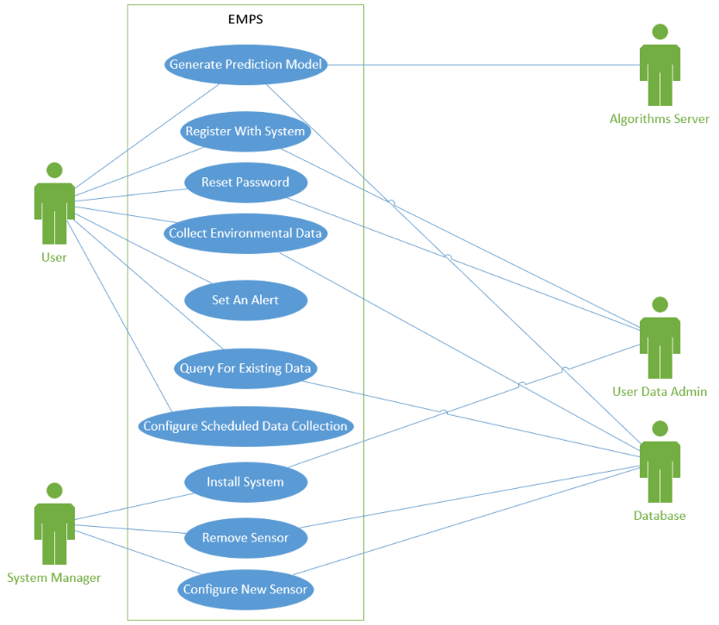

# Domain Model

## Conceptual Classes

|  |  |
| --- | --- |
| **Conceptual Class Category** | **Example from EMPS** |
| **Physical or Tangible Objects** | Environmental Sensors, EMPS UI |
| **Specifications, Designs or Descriptions of Things** | Sensor Readings, Stored Data (from DB), User Account, Success Message, Sensor Data Type, Alert, Predictive Model, Data Query, System |
| **Places** | Region |
| Transactions | Registration |
| Transaction Line Items | Registration Information, Alert Information |
| **Roles of People** | User, User Data Admin, System Manager |
| **Containers of Other Things** | Registration Page, Data Collection Page, Home Page |
| **Things in a Container** | Stored Data |
| **Other Computers/Systems (external)** | Database, Algorithms Server |
| **Abstract Noun Concepts** | Account Creation Error, Data Collection Error, Database Error, Data Fields, Login Error, Insufficient Data Error, Generation Failure Error |
| **Organizations** | Government Agencies, Research Centers |
| **Events** | Data Collection |
| **Processes** | Model Generation |
| **Rules and Policies** | - |
| **Catalogs** | - |
| **Records of Finance, Work, Contracts, Legal Matters, etc.** | - |
| **Financial Instruments and Services** | - |
| **Manuals, Books, Documents, Reference Papers** | - |

### Class Pruning

|  |  |
| --- | --- |
| Good Classes (Retained) | Bad Classes (Pruned) - Reasoning |
| Environmental Sensors | Stored Data - Redundant |
| EMPS UI | User Account - Redundant |
| Sensor Readings | Success Message – Implementation Specific |
| Alert | Sensor Data Type - Attribute |
| Predictive Model | Data Query – Implementation Specific |
| User | System – Vague |
| System Manager | Region – Attribute |
| Database | Registration - Vague |
| Algorithms Server | Registration Page – Implementation Specific |
| Data Collection | Data Collection Page – Implementation Specific |
|  | Home Page – Implementation Specific |
|  | Account Creation Error - Irrelevant |
|  | Data Collection Error - Irrelevant |
|  | Database Error - Irrelevant |
|  | Data Fields - Irrelevant |
|  | Login Error - Irrelevant |
|  | Insufficient Data Error - Irrelevant |
|  | Generation Failure Error - Irrelevant |
|  | Model Generation - Attribute |
|  | Registration Information – Attributes (User Metadata) |
|  | Alert Information - Attributes |
|  | Government Agencies - Irrelevant |
|  | Research Centers - Irrelevant |
|  | User Data Admin - Irrelevant |

## Domain Model Diagram

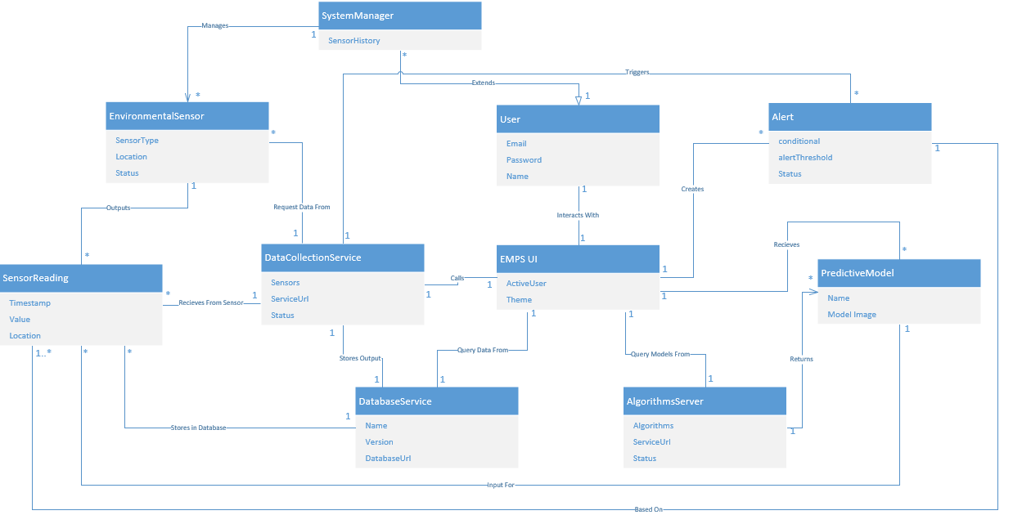

Class Diagram